Report on results and details of Students Satisfaction Survey (SSS) :

Govt. College Narnaund collects the feedbacks/surveys on continuous basis from all the stakeholders. Students Satisfaction Survey (SSS) is one among these surveys. This survey includes majorly the questionnaire recommended by NAAC. Apart from Teaching-Learning and Evaluation aspects, the survey includes mentoring system and students welfare aspects too. The organization of survey, guidelines, questionnaire and the results are provided as follows.

Guidelines for Students :
A student will have to respond to all the questions given in the following format with her/his sincere effort and thought. Her/his identity will not be revealed.

A) Please confirm this is the first and only time you answer this survey.
a) Yes b) No B) Age :
- Branch / Department :
- Gender :
a) Female b) Male c) Transgender
- What degree program are you pursuing now?
a) Bachelor's b) Master’s c) Doctorate

Instructions to fill the questionnaire
- All questions should be compulsorily attempted.

The responses given by the students for the questionnaire provided are given below.

- How much of the syllabus was covered in the class?
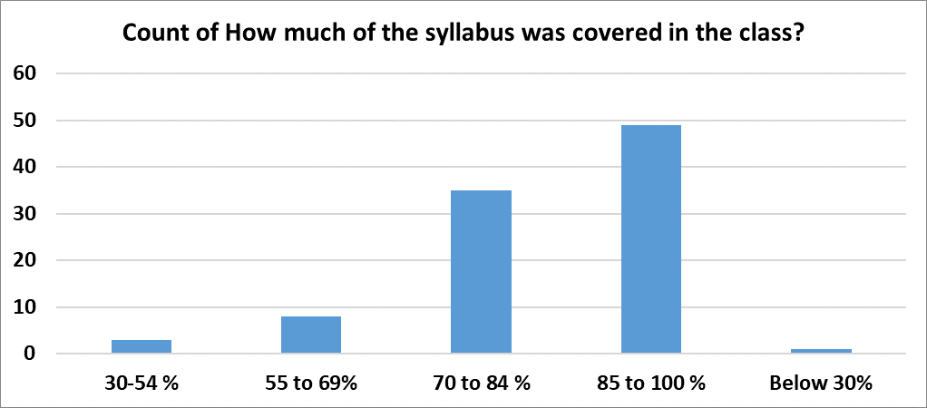

- How well did the teachers prepare for the classes?

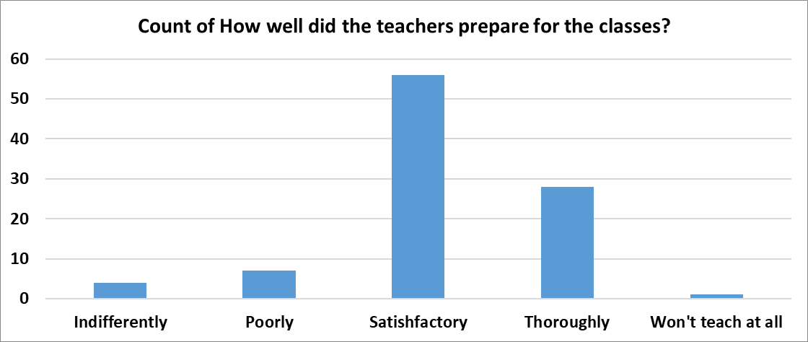

- How well were the teachers able to communicate?
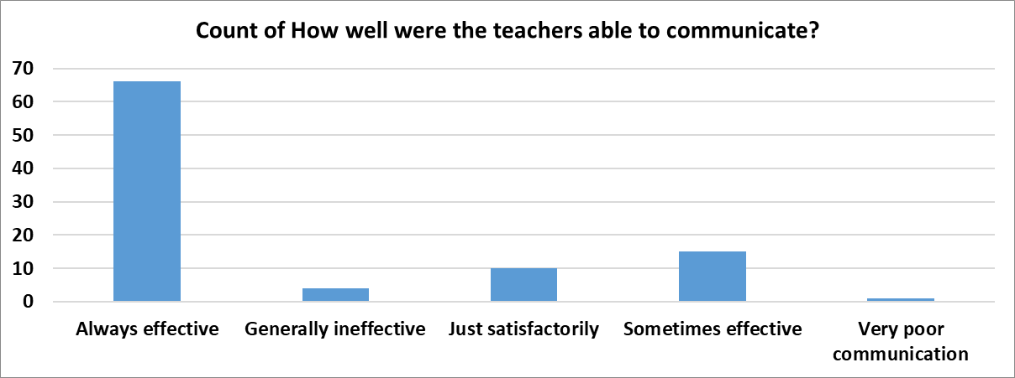

4. The teacher’s approach to teaching can best be described as
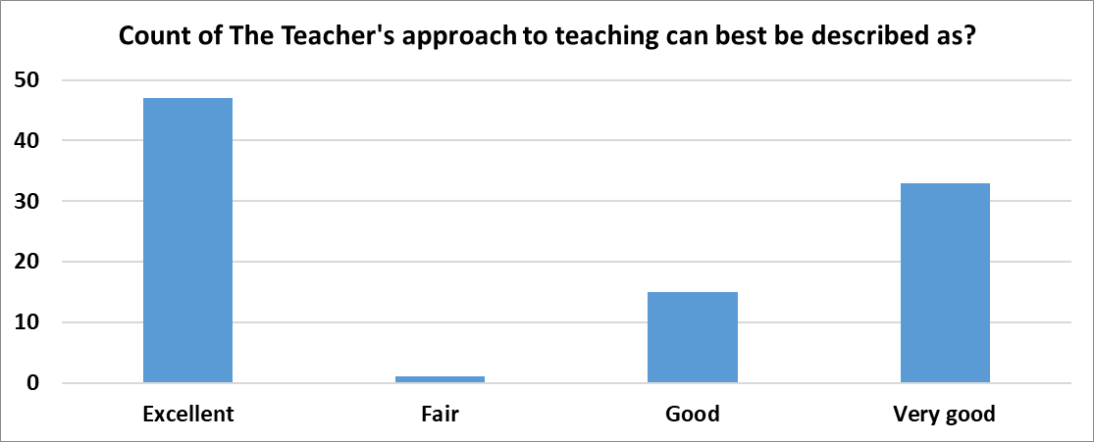

5. Fairness of the internal evaluation process by the teachers
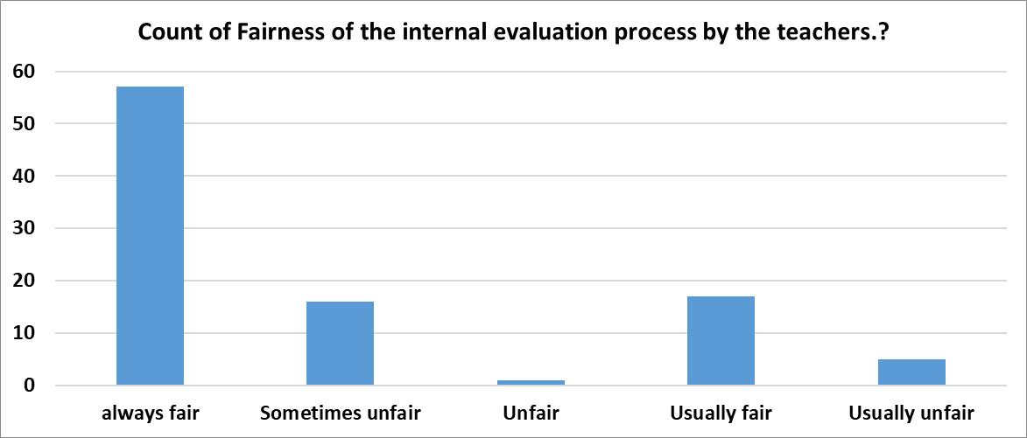

6. Was your performance in assignments discussed with you?
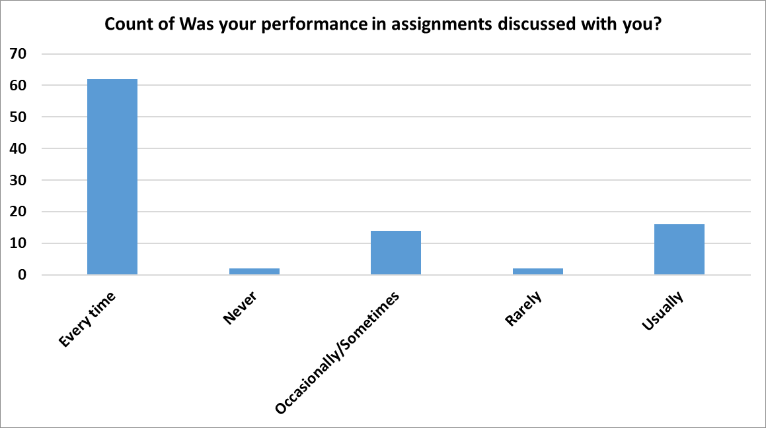

7. The institute takes active interest in promoting internship, student exchange, field visit opportunities for students

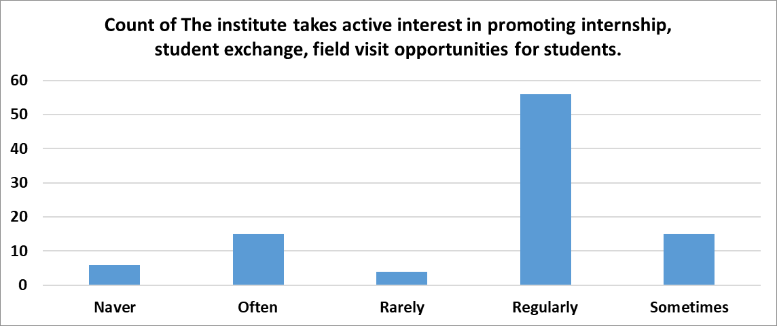

8. The teaching and mentoring process in your institution facilitates you in cognitive, social and emotional growth
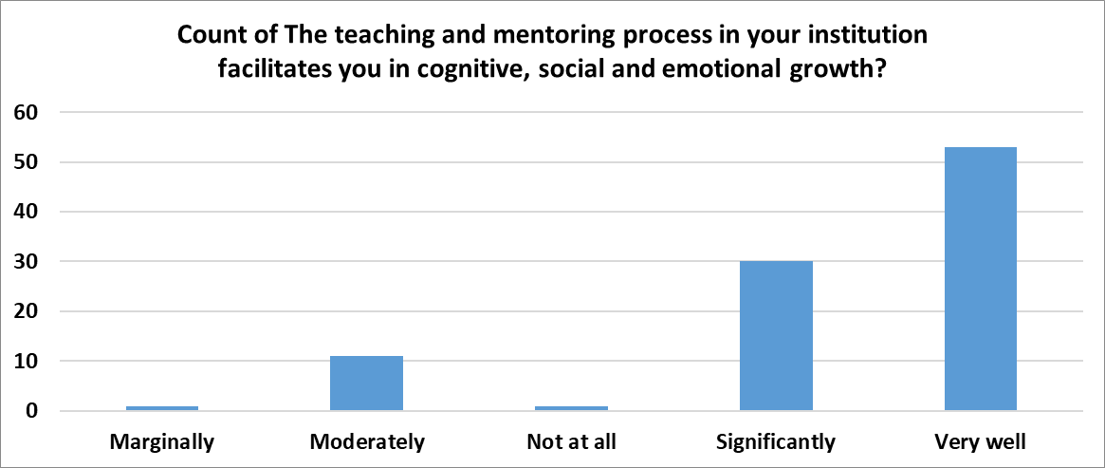

9. The institution provides multiple opportunities to learn and grow
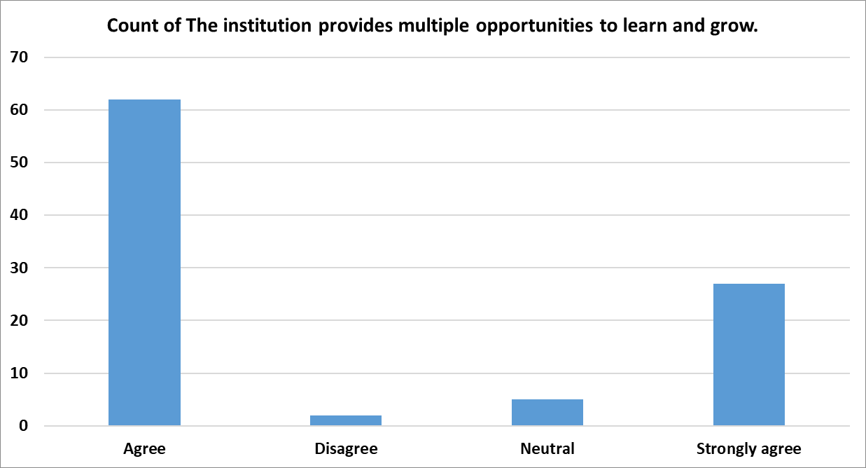

10. Teachers inform you about your expected competencies, course outcomes and programme outcomes
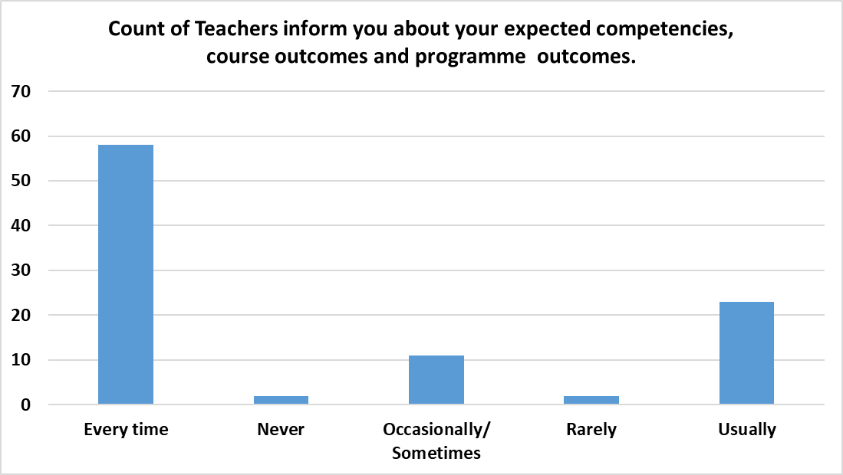\

11. Your mentor does a necessary follow-up with an assigned task to you
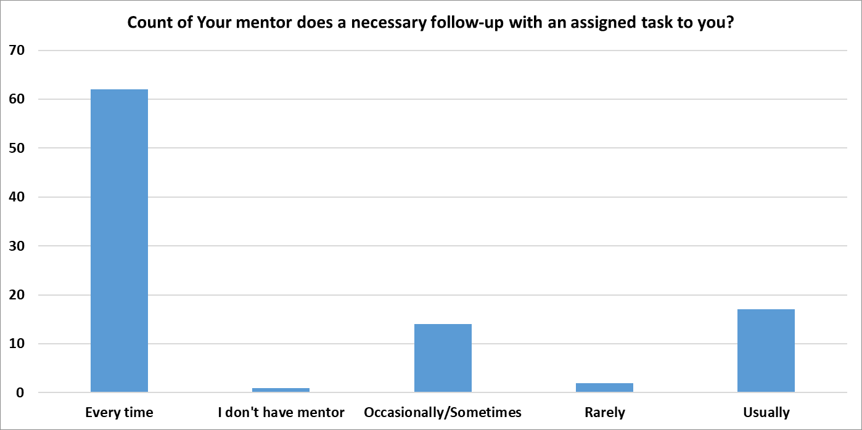

12. The teachers illustrate the concepts through examples and applications
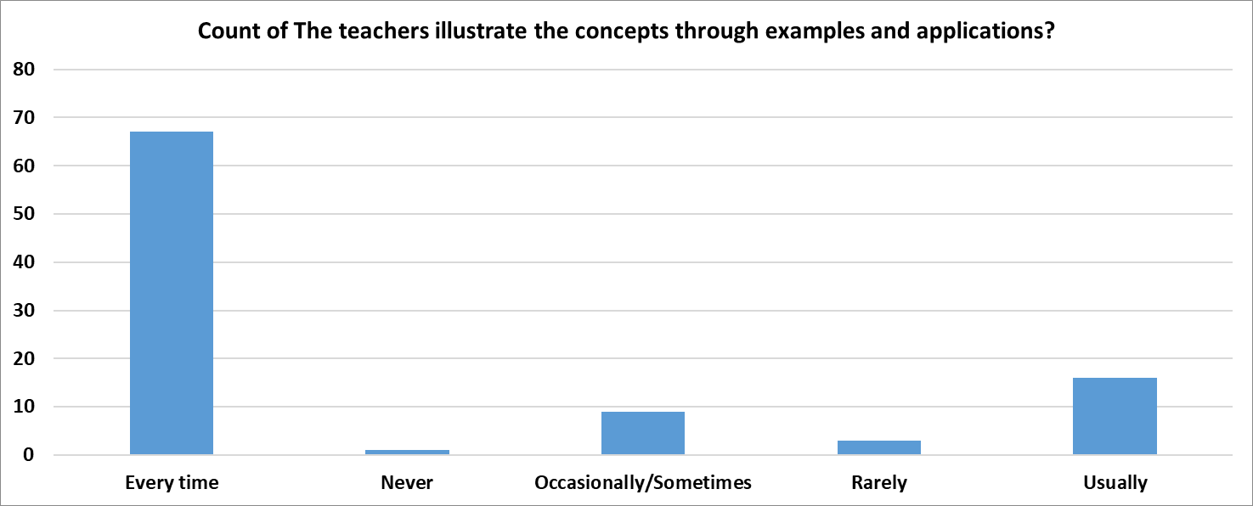

13. The teachers identify your strengths and encourage you with providing right level of challenges
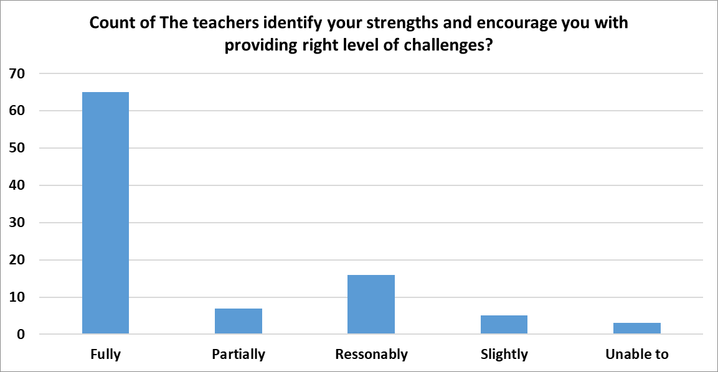

14. Teachers are able to identify your weaknesses and help you to overcome them
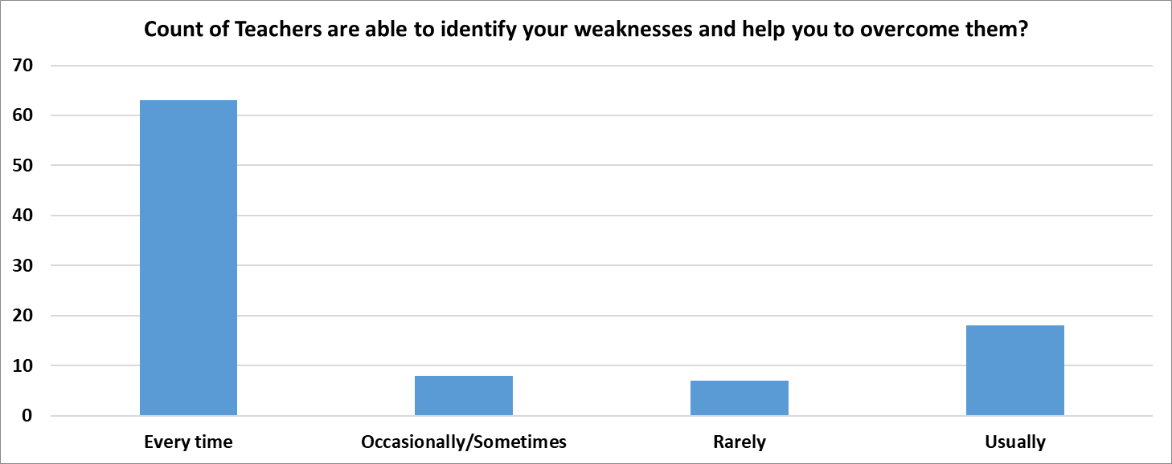

15. The institution makes effort to engage students in the monitoring, review and continuous quality improvement of the teaching learning process
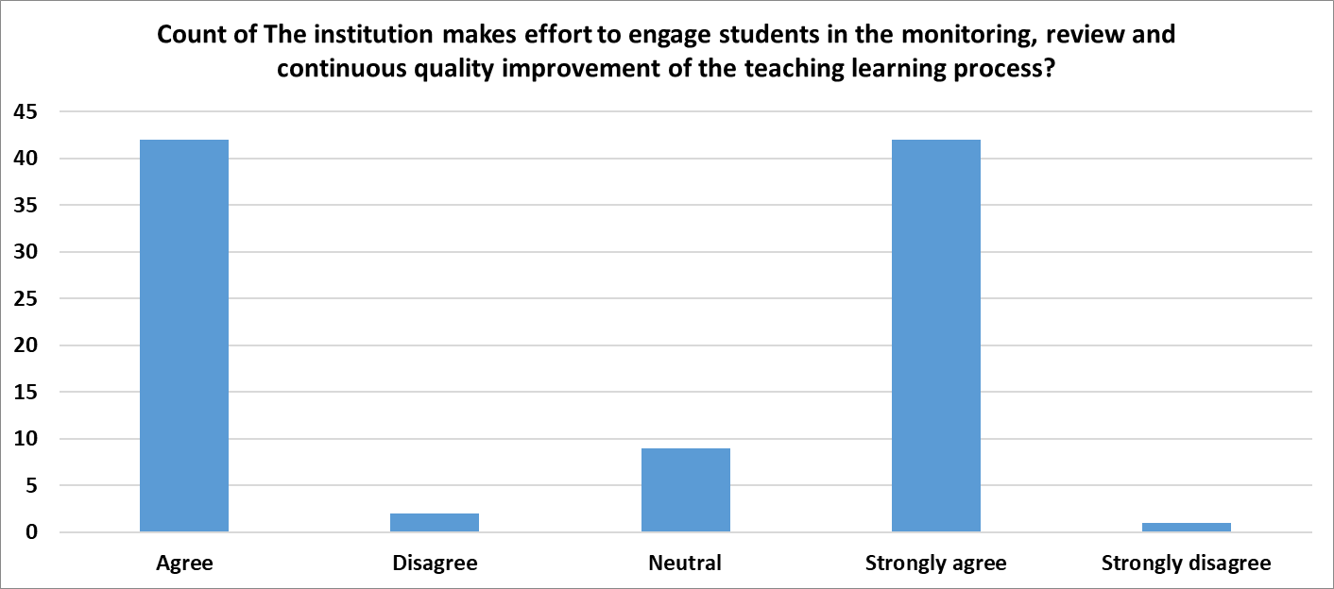

16. The institute/ teachers use student centric methods, such as experiential learning, participative learning and problem solving methodologies for enhancing learning experiences
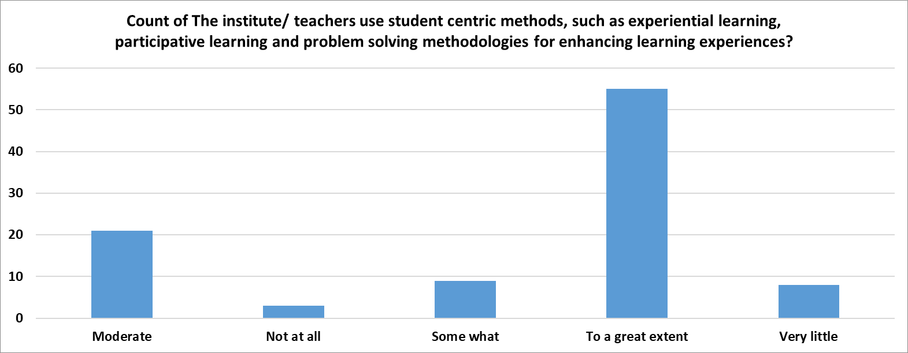

17. Teachers encourage you to participate in extracurricular activities
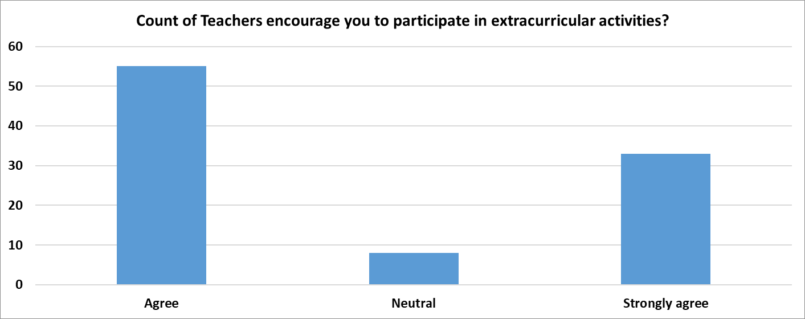

18. Efforts are made by the institute/ teachers to inculcate soft skills, life skills and employability skills to make you ready for the world of work
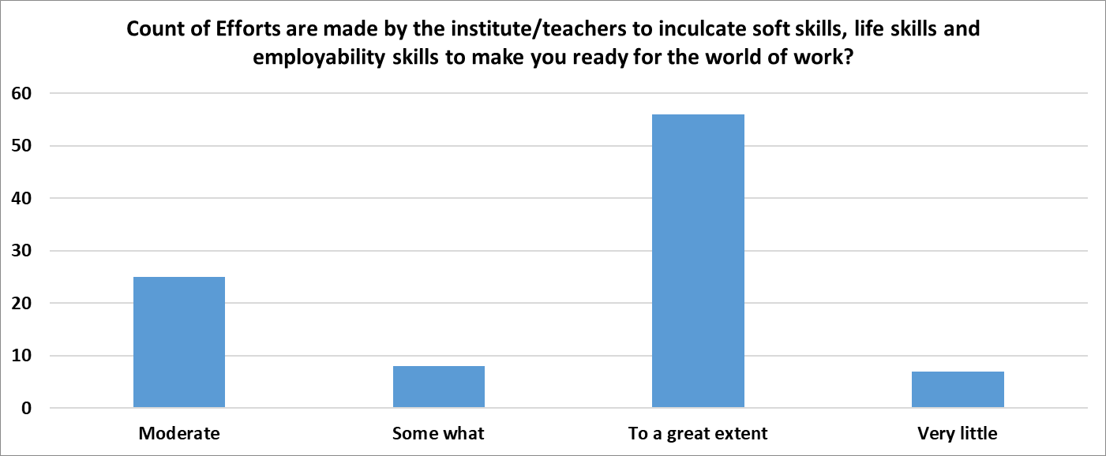

- What percentage of teachers use ICT tools such as LCD projector, Multimedia, etc. while teaching.

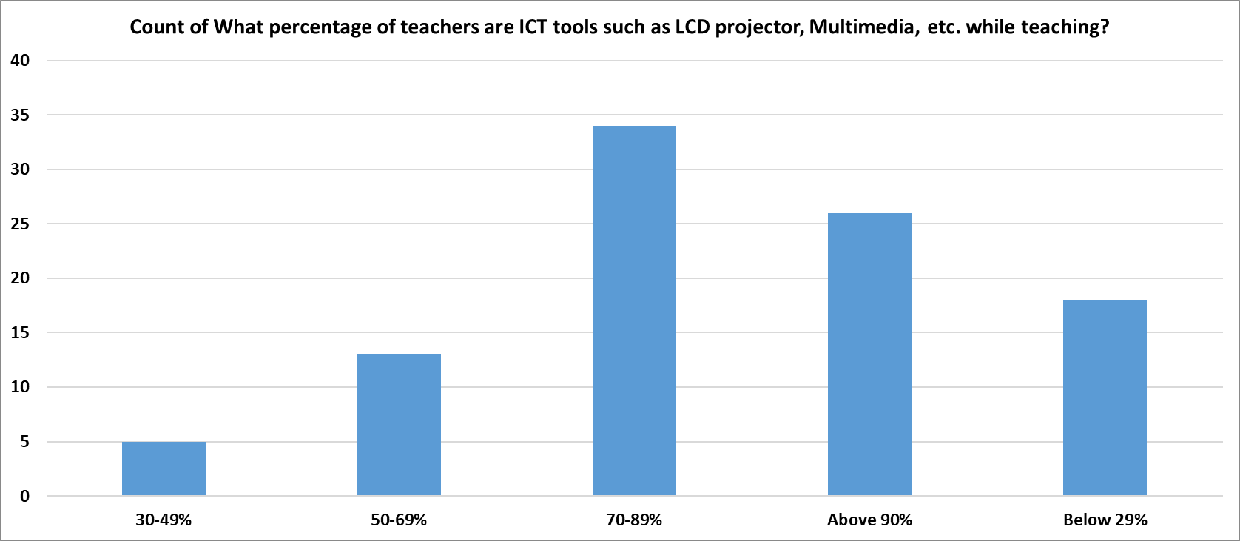
- The overall quality of teaching-learning process in your institute is very good.
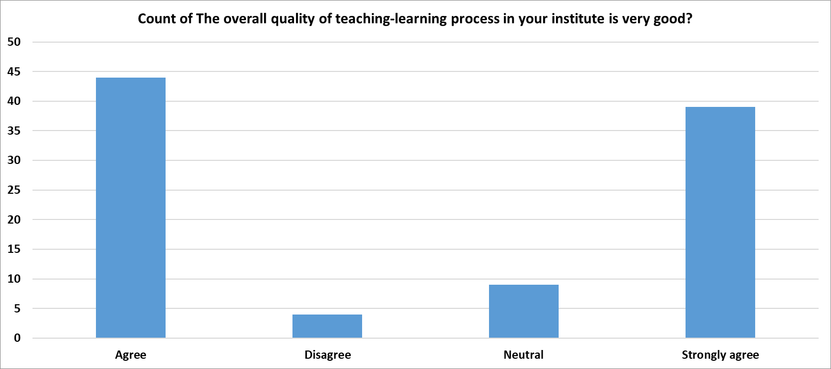

21. Any other suggestions
- Excellent teaching, nice practical knowledge and overall best in all factors.
- The teaching style and the learning is going perfect.
- Faculty are very much interested in explaining subject oriented examples. ✓ More interaction with teachers and students
- Facilities are good.

The teaching and learning process in the institute with the implementation of modern and distinctive pedagogical methods, could gain the satisfaction levels up to excellent. In overall, 86.46% students agreed or strongly agreed with the statement that the quality of teaching-learning process in the institute is very good.

